Staff Report
Meeting Date: February 20, 2023
To: Siskiyou County Board of Supervisors
From: Bernadette Cizin, Associate Planner
Subject: Proposed McMahon Agricultural Preserve Amendment, Williamson Act Rescission with Re-entry, Agricultural Preserve Amendment (APA-23-21) and CEQA Determination

Background and Discussion
On October 12, 2023, the County received an application for a Boundary Line Adjustment with a minor Zone Change. The applicant proposes to adjust the boundary between family-owned parcels, transferring a portion of property utilized for the ranch from an adjacent residential property. It was found that even though the 18-acre residential parcel is not currently encumbered by a Williamson Act Contract, it remains within the same Agricultural Preserve as the ranch. A contract amendment is required as the project proposes to increase the acreage under contract by 8 acres (shown in Figure 1). Also, during the review of the property to remain under the existing contract, it was found that it is comprised of several substandard parcels which should be issued a notice of non-renewal.
The subject property has been used for and continues to be used for livestock grazing.
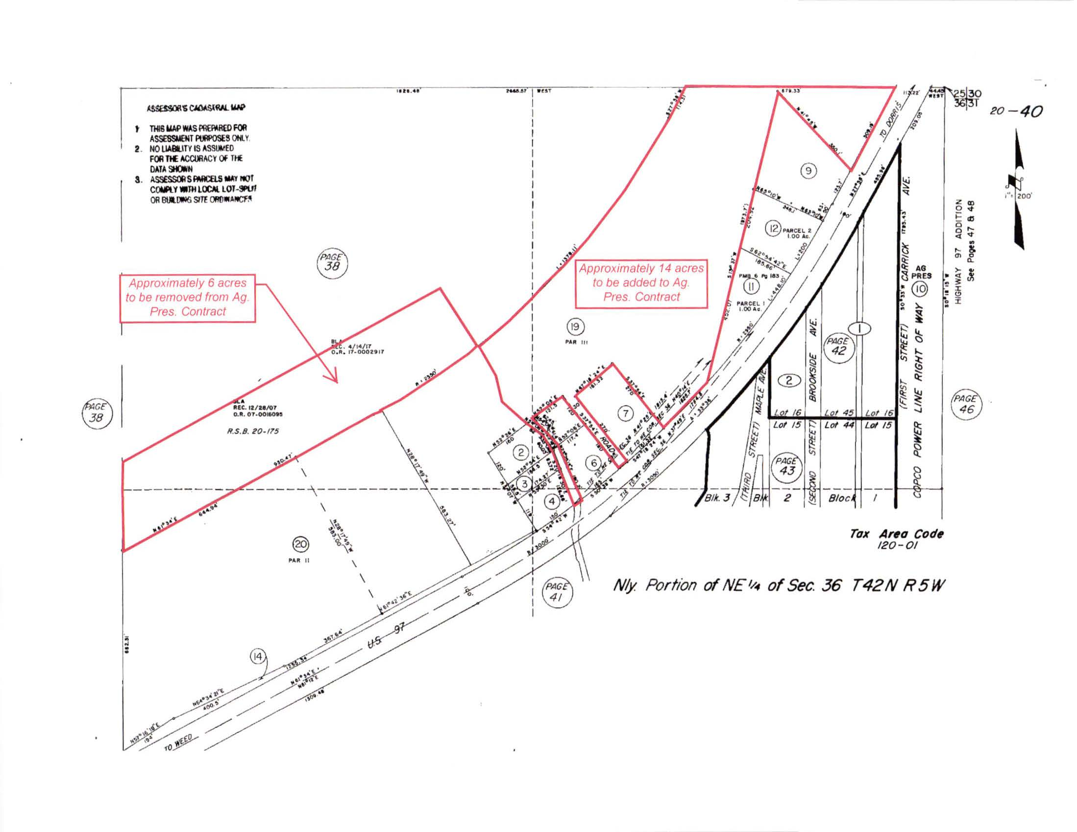
Figure 1: Subject Property
Agricultural Preserve Administrator Review
Staff prepared a detailed report (Exhibit C) for review and recommendation by the Agricultural Preserve Administrator. Based on the report, the Administrator found the applicant’s request, including the 8 acre increase in acreage under contract, is consistent with the County Rules for the Establishment and Administration of Agricultural Preserves and Williamson Act Contracts and recommends the Board rescind and reissue the contract, to include 8 acres not previously under contract, as proposed and amend the existing preserve to remove the subject property and establish a new agricultural preserve. The Administrator also recommends issuing a notice of non-renewal for the remaining properties under the existing contract as they are substandard in size, each being less than 5 acres.

Environmental Review
Staff is proposing that the project and issuance of notice of non-renewal be considered categorically exempt from the California Environmental Quality Act (CEQA) pursuant to CEQA Guidelines Section 15317, Open Space Easements or Contracts. A Categorical Exemption implies that the project will not result in any significant adverse environmental effects. CEQA Guidelines Section 15317 specifically exempts the making and renewing of open space contracts under the Williamson Act, which is applicable to the subject action.
The Board of Supervisors must consider the proposed CEQA exemption together with any comments received during the public review process. Further, the exemption can only be approved if the Board finds, based on the whole record before it, that there is not substantial evidence that the project will have a significant effect on the environment. Accordingly, a finding to this effect has been incorporated into both draft resolutions prepared for the Board’s consideration.

Comments
Agency Comments
Siskiyou County Assessor – January 10, 2024
The Assessor’s office has provided estimated tax assessment values for the three parcels included in this project (Exhibit E).
Public Comments
Notice of the project was published and posted as required prior to the Board of Supervisors meeting and no public comment was received as of the preparation of this staff report.

Recommended Action
Should the Board of Supervisors concur with staff’s analysis, staff recommends that the Board of Supervisors find that the proposed modifications to the Williamson Act contract and Agricultural Preserve are exempt from CEQA and approve said modifications.
A draft motion to this effect is provided below.

Recommended Motions
I move to take the following actions:
- Determine the project exempt from CEQA in accordance with Section 15317, Open Space Easements or Contracts; and
- Adopt the attached resolution approving amendment to the existing Agricultural Preserve and establishment of a new preserve; and
- Adopt the attached resolution approving the rescission and reentry of the applicable Williamson Act contract which includes the 8 acres previously not encumbered by contract; and
- Adopt the attached resolution directing staff to process the Notice of Non-Renewal for the substandard parcels remaining under the existing contract, with any changes directed by the Board.

Exhibits to the Staff Report
- Draft Resolution amending the existing Agricultural Preserve and establishing a new preserve
- Draft Resolution Approving the Rescission of the subject property from the existing contracts and Reentry into a new Williamson Act Contract
- Exhibit A within Draft Resolution: Williamson Act Contract Resultant Parcel One – Draft
- Draft Resolution directing staff to issue a Notice of Non-Renewal for the 12.39 acres consisting of substandard parcels
1. Exhibit A within Draft Resolution: Notice of Non-Renewal - Draft
- Agricultural Preserve Administrator Staff Report with Recommendation
- Comments

